ATP-10998
Policy conversion defect: Business details screen Q0113196 - 1st sept batch

Description

The questions under “Do you retail or manufacture tyres?” is Yes in PURE data but DC UI has nothing selected and data coming is 0 in clarity and UI for other fields under that sub section where as in PURE this policy has below data:
3 ISSUES BELOW:
- sales secondhand tyre % is 1% but clarity and UI =0
- heavy transport tyre turnover has value in clarity but UI doesn't show it?
- sales sceondhand turnover amount coming in clarity but UI has 0 value?

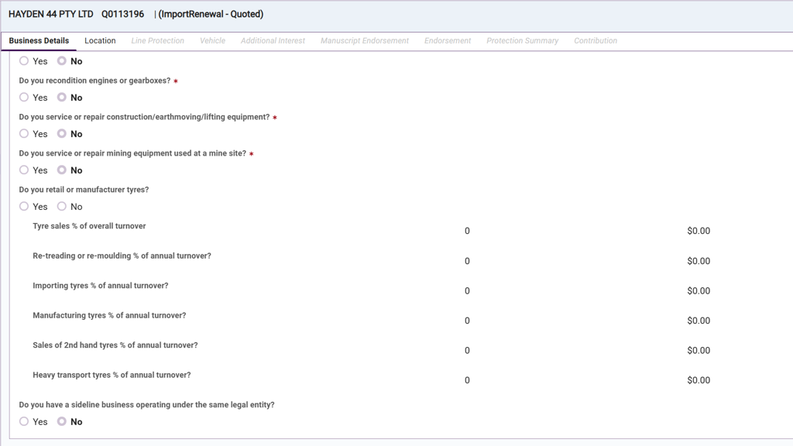
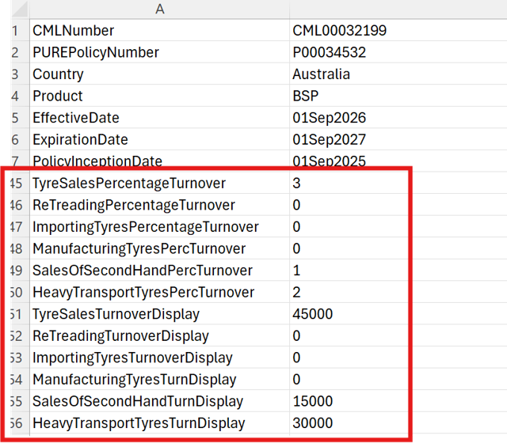

ATP-10949
Policy conversion defect - Location coverages BC screen: Contents Limit populating a value when it's 0 in PURE data

Description

Tested on 30062026, 1st September Batch and the below policies show that contents limit is retrieving a value when PURE’s data is 0.

PURE_Pol | DC_Pol | DC_Status | DC_Batch | Data_Type | street_join | Vehicle | Field | PURE | DC | Match
P00023336 | Q0113140 | Referred | 26/06/2026 | Location Coverages | 1 TOMBO ST | NA | BC Standard | 0 | 32000 | 0
P00034238 | Q0113099 | Referred | 26/06/2026 | Location Coverages | 32A MUNT ST | NA | BC Standard | 0 | 32000 | 0

Issue: This policy did not have any Location coverages migrated. Could we please investigate why it's a broken renewal? As you can see below PURE has 2 location coverage but DC has nothing.
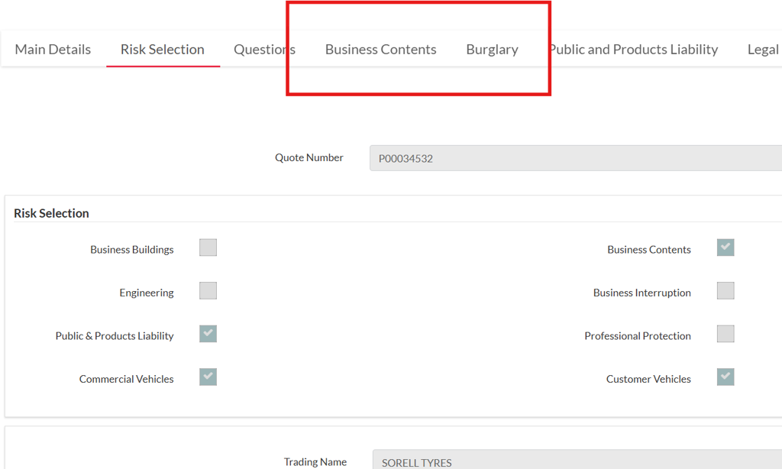

Clarity:
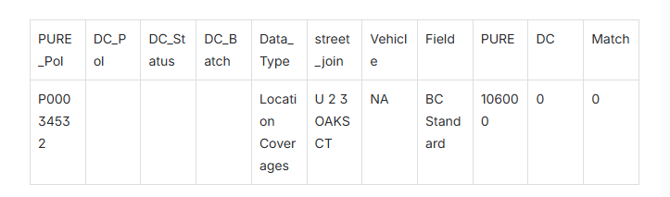
UI
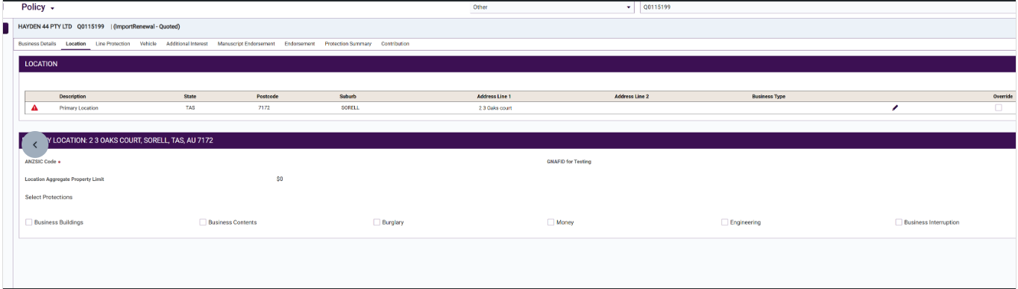
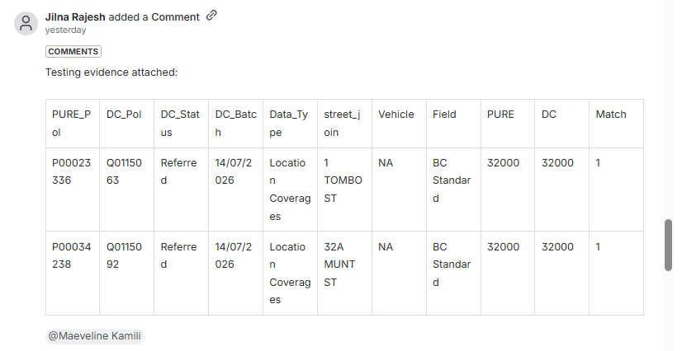

ATP-10947
Policy conversion defect - Location coverages BC screen: Landslide Limit showing incorrect values in Clarity compared to UI
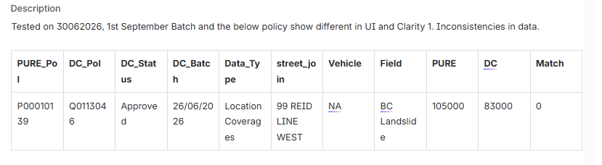
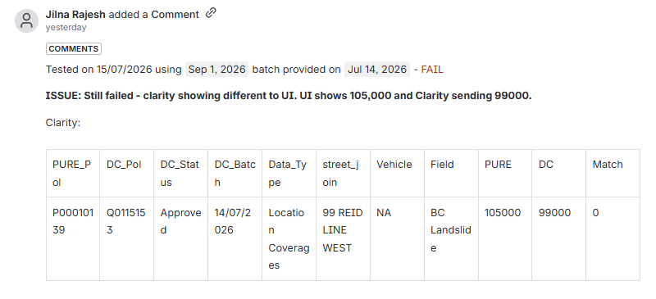

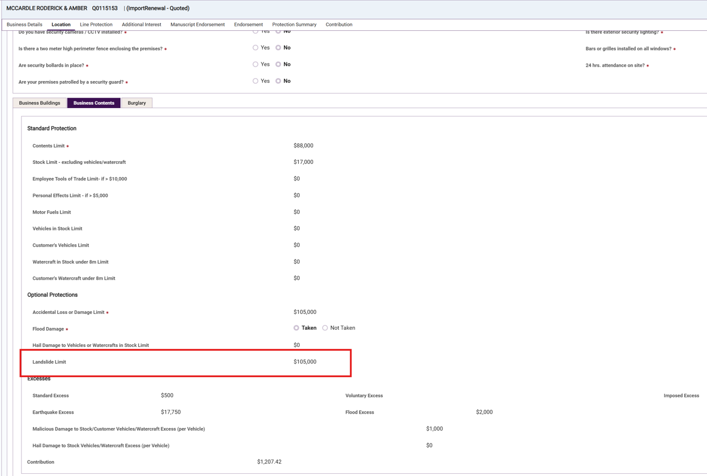

ATP-10950
Policy conversion defect - Location coverages BG screen: Contents, Stock & Employee Tools Limit populating a value when it's 0 in PURE data
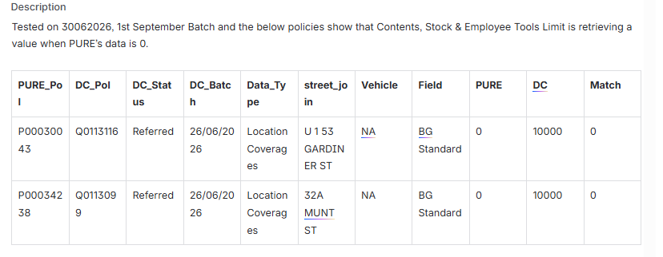
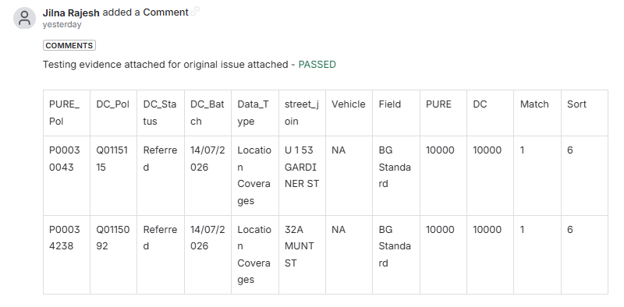
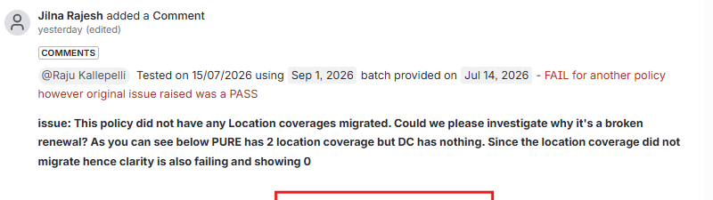
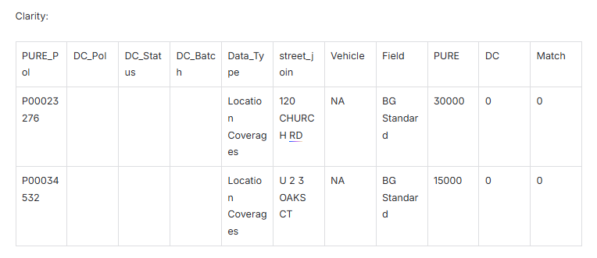
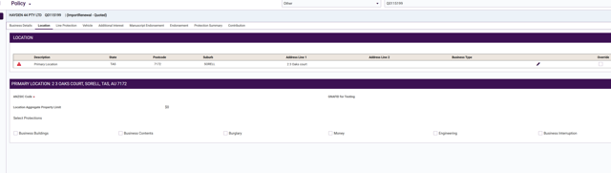

ATP-10960
Policy conversion defect - Location coverages BG screen: Theft Limit for NZ is incorrect in UI when "Theft Limit" >= "Contents, Stock & Employee Tools Limit"

Description

Tested on 30062026, 1st September Batch and the below policies show incorrect values for “Theft Limit” when “Theft Limit” >= "Contents, Stock & Employee Tools Limit" for NZ.

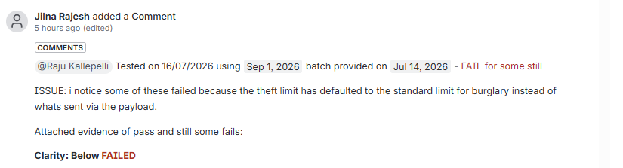
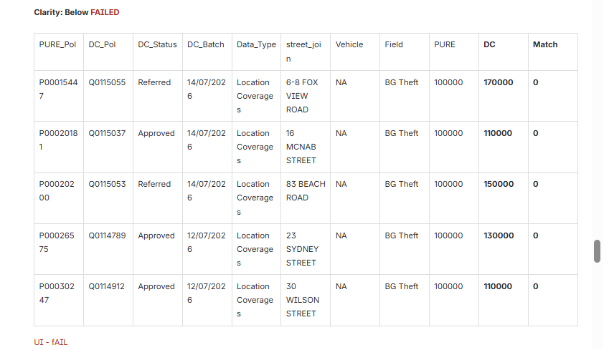

UI – fAIL

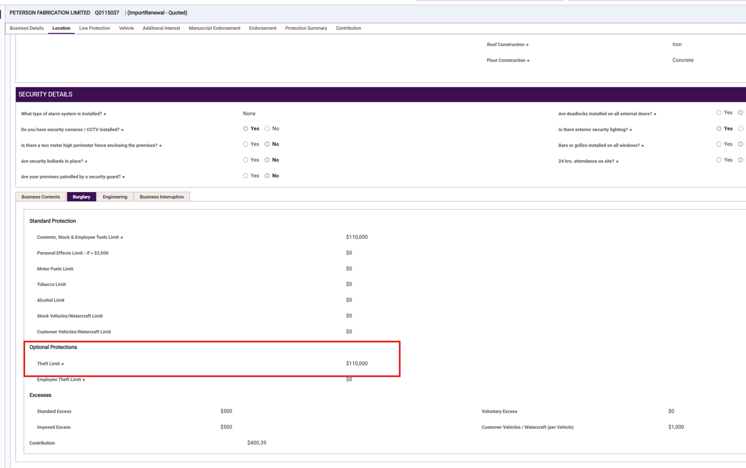
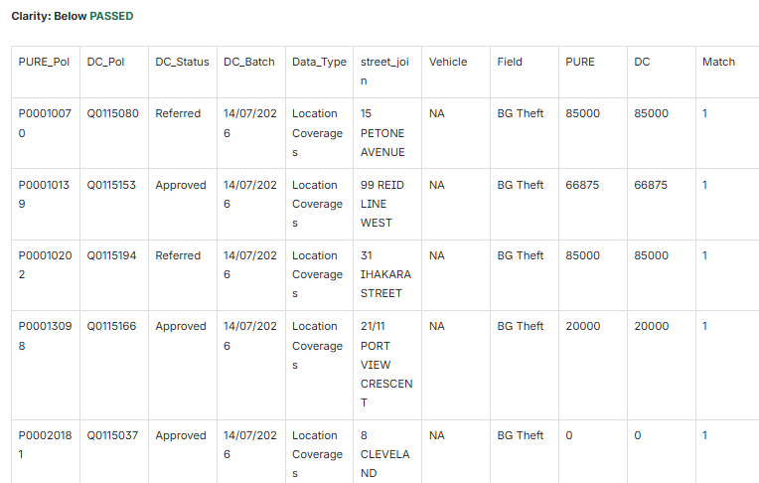
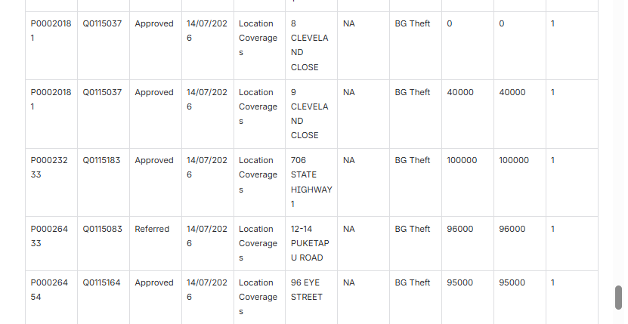
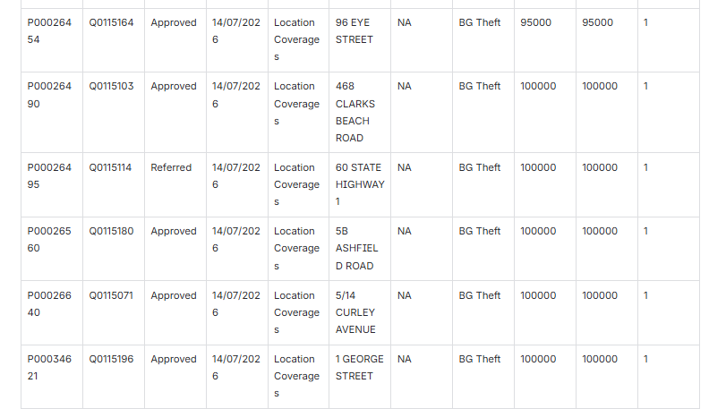

UI -pass
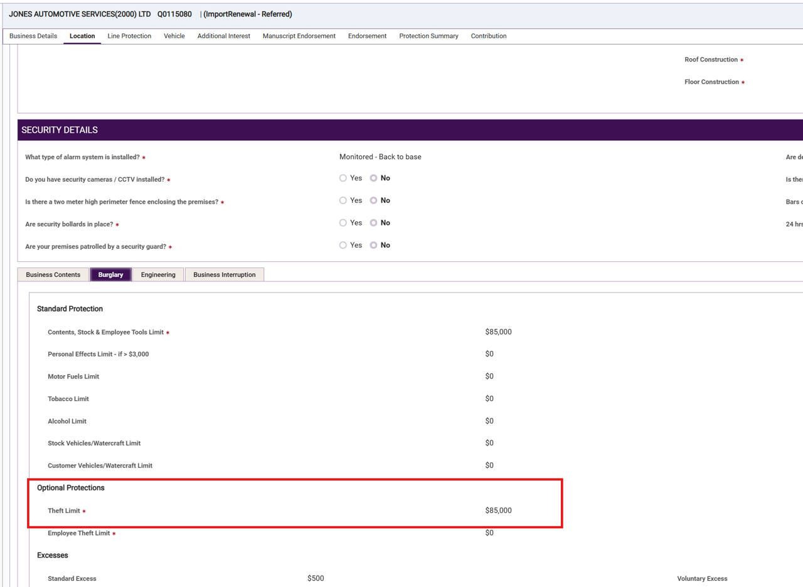

ATP-10952
Policy conversion defect - Location coverages EN screen: Voluntary Excess not returning a value in UI

Description
Tested on 30062026, 1st September Batch and the below policies show that voluntary excess is not retrieving a value in UI.

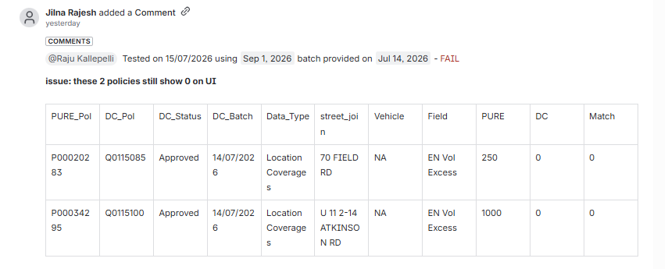
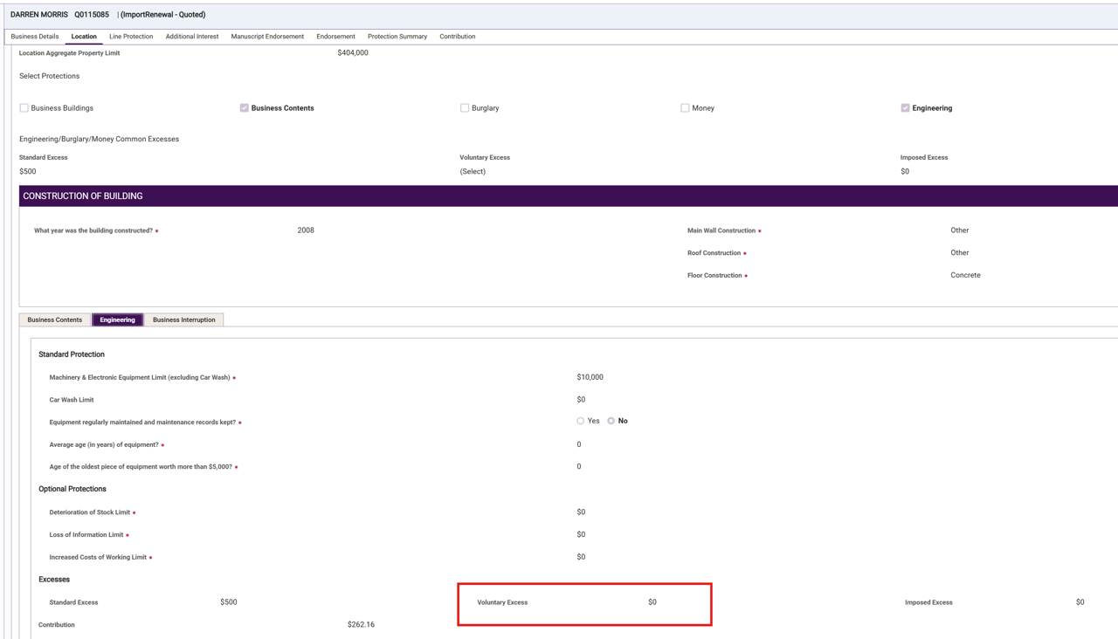

ATP-10980
Policy conversion defect - Additional Interest screen: Some data missing and incorrect - Q0113129

Description

Tested on 01072026, 1st September Batch and the below policy is not showing all the interested parties, and some are showing incorrect values (P00010027).

